Batch 4: Algorithmic trading assignment C++ for Internship at Envirya
Name: Pranav Mukane
Contact no: 9967783202/pranavmukne1498@gmail.com/pranavmukne@iitkgp.ac.in
Identify instances when strategy 1 happened, you need to get following information:
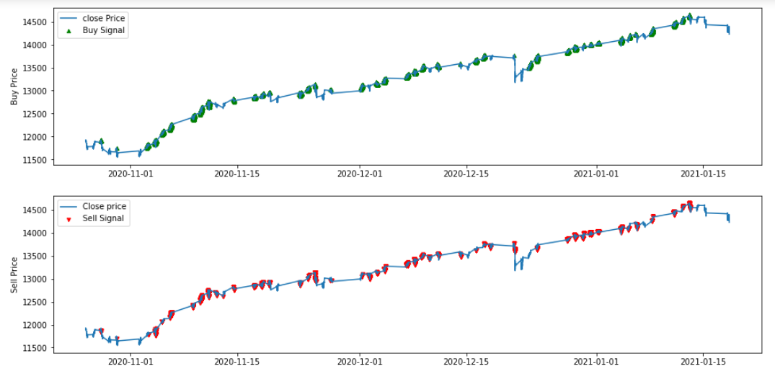
Above graph where data points are plotted using python shows various instance where strategy was met. Green point shows ‘Buy’ signal points and red markers shows ‘Sell’ signal points. We have many points where strategy was met only few of them met the target points and many of time strategy met stop loss. In this section let us discuss few instances where strategy was met and target was achieved. We try to keep answers comprehensive as much as for understanding.
- What time in a day strategy 1 occurred
Ans. Below list shows the time on 2020-11-24 where strategy 1 occurred but met stop loss condition and was executed.
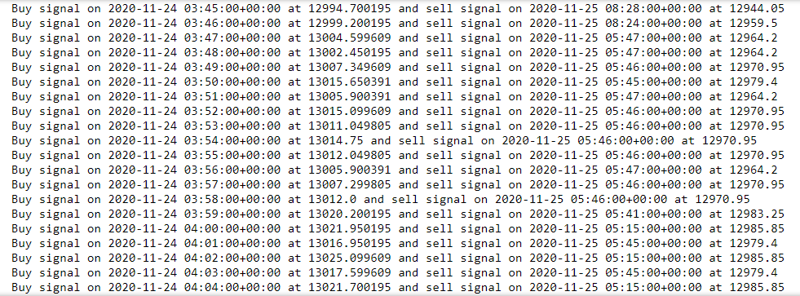
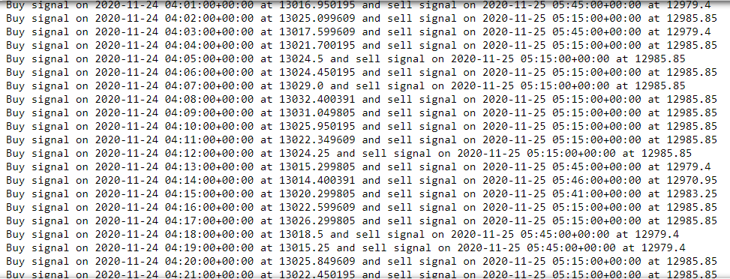
Below list shows the time on 2020-11-24 where strategy 1 occurred but met target condition and was executed.
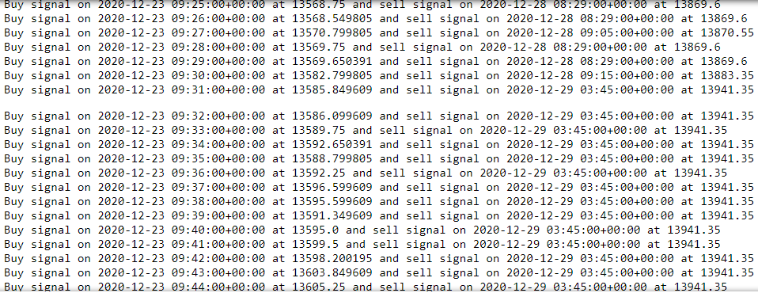
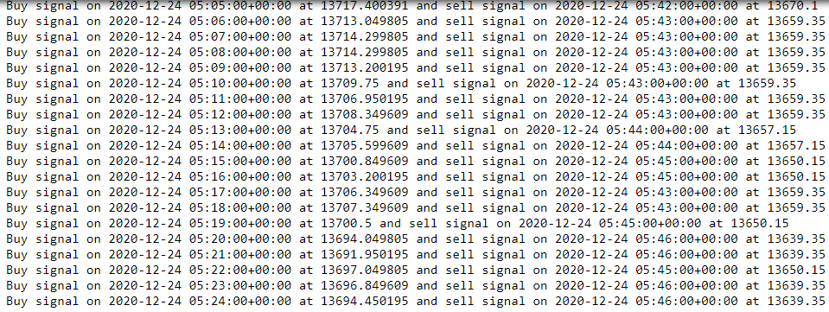

- How many times it happened in the course of the given time period (26-October-2020 to 18-January-2021)
Ans. We see that the strategy takes place at various instance in the course of the given time period of (26-October-2020 to 18-January-2021) around 10221. And we noticed that the around 4021 time if buy condition is satisfied then target profit is met. Around 6200 time stop loss is met. This are few dates between 26-october-2020 to 18-jan-2021 where strategy most likely occurred 2020-11-14, 2020-11-17, 2020-11-18, 2020-11-19, 2020-11-23, 2020-11-24, 2020-11-27, 2020-12-01, 2020-12-03, 2020-12-04, 2020-12-07, 2020-12-08, 2020-12-11, 2020-12-16, 2020-12-17, 2020-12-21, 2020-12-23, 2020-12-24, 2020-12-28, 2020-12-29, 2020-12-30, 2020-12-31, 2021-01-01, 2021-01-05, 2021-01-06, 2021-01-08, 2021-01-11, 2021-01-12, 2021-01-13 .

- If the strategy 1 occurred how much profit trader made assuming number of stocks bought were 10 when the trade was "Active".
Ans. To solve above question we make an assumption that all the open, high, low, close data of nse as real price of the stock. Once the first condition is met, current close price crosses previous day's high stock is bought. Let us take the above situation where we showed plot and extract trade status of "2020-12-24", the strategy recommends the trade to buy stock at the time "03:45:00+00:00" and advice to sell the stock on '2020-12-28 03:48:00+00:00'. So buying price is Rs.13669.299805 and trade is executed at the sell price Rs.13858.30. Assuming that the number of stocks bought were 10 when trade status was given active.
Now we see that target price is Rs.13856.54981 and stoploss Rs.13622.48731. We see that graph shows increasing trend around 2020-12-24 and selling price is Rs.13858.30 which is greater than target price Rs.13856.54981. Therefore trade was excecuted on
'2020-12-28 03:48:00'. Although we notice in the graph that the close value is increasing and we could have executed the trade manually at high price by waiting, since we have set the target price the compiler we execute the trade once target is met.
So profit booked is (Selling price - Buying price)*Quantity of stocks bought which is (Rs.13858.30-Rs.13669.299805)*10.Profit made by trader when trade was Active is Rs.1890.0019499999871.

Let’s take the above situation where we showed plot and extract trade status of "2020-11-24", the strategy recommends the trade to buy stock at the time "03:55:00+00:00" and advice to sell the stock on '2020-11-25 05:46:00+00:00'. So buying price is Rs.13012.049805 and trade is executed at the sell price Rs.12970.95. Assuming that the number of stocks bought were 10 when trade status was given active.
Now we see that target price is Rs.13155.2 and stop loss Rs.12976.26. We see that graph shows some decreasing trend around 2020-11-24 and selling price is Rs.12970.95 which is less than stop loss price Rs.12976.26. Therefore trade was executed on '2020-11-25 05:46:00+00:00'., since we have set the stop loss the compiler execute the trade once stop loss is met around nearest date of buying the stock to hear trader has to bear loss.
So profit booked is (Selling price - Buying price)*Quantity of stocks bought which is (Rs. 12970.95-Rs. 13012.049805)*10 = Rs.410.99805.

